2022 Enter the Den
Contest Submission

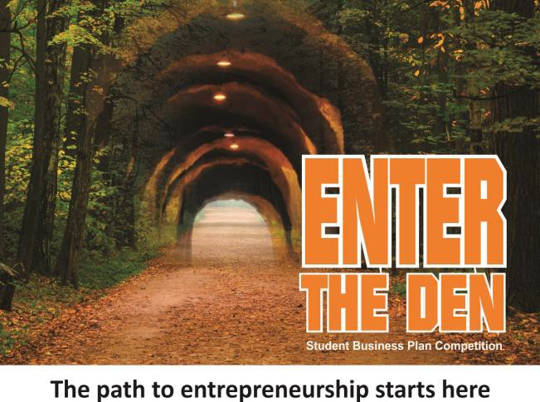 | Entry Deadline March 23, 2022  Semi-Finals April 12 & 13, 2022  Finals May 3, 2022
Whether you have a business idea or just considering what entrepreneurship (self-employment) is about, we encourage you to submit your business idea to the Enter the Den Business Plan Competition.

Personal Information

Name:
Team Members: (if applicable)
School: | Grade:
Email: | Phone:
Mailing Address:

Business Name: __________________________________________________

Describe your idea in 3 sentences or less:

What best describes your idea? (Circle one)

Physical product Wholesale Business Service Software
Other:

What does your business/product do?

Sell us your idea!

For example, start with “We provide” or “My product will” …How is your business or product unique?
For example “In comparison with other ….. we …..” …What problem or need does your business address or fill?
For example: “we improve“or “we simplify“ …How much money would you need to start your business?

My/Our business idea …

Please note: Thanks for submitting an application to the ‘Enter the Den’ contest. You should give as much information as necessary to enable us to assess your business idea or product BUT SHOULD NOT DISCLOSE ANY INFORMATION WHICH IS TO BE TREATED AS CONFIDENTIAL OR TRADE SECRETS. You must not include any details on any application or process, which may be patentable unless you have secured the patent, or this is pending - to do so may invalidate any patent application you later make, and you are doing so at your own risk and peril.

Rules and Regulations:
The Contest:

Enter the Den is a business plan competition for Thunder Bay school students inspired by the popular Canadian TV show, the Dragon’s Den. Enter the Den is a gentler version of the format with practical feedback to semi-finalists and finalists.

The three cash prizes in each category will go to students with good business ideas that have been well researched, well presented, and well defended. Both written and verbal presentations will be required, and we would expect that the winners would follow the format of a business plan in developing their business idea.

This contest offers encouragement and supports students along the way. Several resources and supports will be available to assist students moving forward in the competition. This includes tips on writing the business plan, marketing do's and don'ts, presentation skills and more.

Students do not have to start the business - the goal is to learn what is involved in starting a business and realizing that starting a business can be a career choice.

How Enter the Den Works:

Application: Develop your idea and submit your APPLICATION by the posted date. We recommend you discuss and review your application with one of your school's business teachers prior to submission.

Business Plan Preparation: After the due date, we will contact you by email or phone and let you know if you have been selected to proceed to the next round of the contest. You will have 48 hours to inform Thunder Bay Ventures of your intent to participate. If you’re selected to go to the next round, then it’s time to prepare your business plan. Again, we strongly recommend students seek guidance from their business teachers in the development of their business plans.

Semi-Finals: Students selected for the semi-finals will present and defend their business plans to a panel of judges. Please make sure you have practiced your verbal pitch and are familiar with all your details, as you will be asked questions. You may use video, audio recordings, PowerPoint presentation or other media to convey your ideas, however it is not a requirement.

Finals: Students chosen to move forward to the finals will receive feedback on how to improve their presentations before the next round with new judges.

Permission and Authorization:

I hereby acknowledge and agree that I am voluntarily providing the foregoing information below in consideration of possible selection as a participant in the ‘Enter the Den’ contest presentations. I understand and agree that Thunder Bay Ventures, contest partners and sponsors are under no obligation to interview me, to select me as a participant in the contest semi-finals or finals, and the information provided herein is merely for the purpose of evaluating my potential as a semi-finalist in the contest.

I acknowledge that all the information provided on this application is true and accurate, and any false or misleading information submitted herein is grounds for my immediate elimination from consideration.

I agree to fill out and execute further documents as required by the contest sponsors and judges in connection with the contest.

Date:
Signature:
Are you under 18? (Circle one): Yes No
* If you’re under 18, a parent/guardian must fill out
below to consent your participation in the contest

I, consent to my child
Parent/Guardian’s Name (please print)
participating in all Enter the Den events

Parent/ Guardian's Email or Phone

______________________________
Parent/Guardian’s Signature

____________________________

Media Release:
To be filled out by a student over the age of 18 or by
legal parent/guardian on the student’s behalf.
I agree that if I am selected for the semi-finals and/or finals of the Enter the Den contest, Thunder Bay Ventures has the right to use my name and image for promotional purposes.

Date: ___________________
Signature: ___________________

Teacher Review of Application:

We encourage all students to have one of their teachers look over their application and sign below before submitting it for review.

Date: _______________________

Signature: ________________________

Thunder Bay Ventures is compliant with all Privacy Legislation in Canada and your personal information collected here will not be disclosed, sold,
rented, leased or made available to anyone for the expressed use of this “Enter the Den” contest. Their complete privacy policy can be found at www.thunderbayventures.com.
By email: enterthedentbay@gmail.com
How to Submit Your Application:
By Mail: Thunder Bay Ventures, Box 10116, Thunder Bay, ON P7B 6T6

In Person: 1043 Gorham Street, Unit D

